1. 在pom.xml文件中配置依赖项

*<!--引入Spring Boot内嵌的Tomcat对JSP的解析包-->*<**dependency**>  
 <**groupId**>org.apache.tomcat.embed</**groupId**>  
 <**artifactId**>tomcat-embed-jasper</**artifactId**>  
</**dependency**>  
  
*<!--servlet依赖的jar包-->*<**dependency**>  
 <**groupId**>javax.servlet</**groupId**>  
 <**artifactId**>javax.servlet-api</**artifactId**>  
</**dependency**>

*<!--jsp依赖jar包-->*<**dependency**>  
 <**groupId**>javax.servlet.jsp</**groupId**>  
 <**artifactId**>javax.servlet.jsp-api</**artifactId**>  
 <**version**>2.3.1</**version**>  
</**dependency**>

*<!--jstl标签依赖的jar包-->*<**dependency**>  
 <**groupId**>javax.servlet</**groupId**>  
 <**artifactId**>jstl</**artifactId**>  
</**dependency**>

1. 在application.properties文件配置spring mvc的视图展示为jsp：

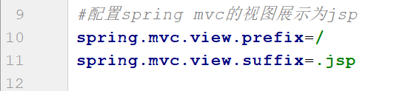

1. 在src/main下创建一个webapp目录，然后在该目录下新建jsp页面
2. build中要配置备注中的配置信息

<**resources**>  
 <**resource**>  
 <**directory**>src/main/java</**directory**>  
 <**includes**>  
 <**include**>**/*.xml</**include**>  
 </**includes**>  
 </**resource**>  
 <**resource**>  
 <**directory**>src/main/resources</**directory**>  
 <**includes**>  
 <**include**>**/*.*</**include**>  
 </**includes**>  
 </**resource**>  
 <**resource**>  
 <**directory**>src/main/webapp</**directory**>  
 <**targetPath**>META-INF/resources</**targetPath**>  
 <**includes**>  
 <**include**>**/*.*</**include**>  
 </**includes**>  
 </**resource**>  
</**resources**>